Sustainable Wales & USW
Global Community Awards
ENTRY FORM
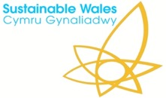
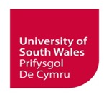
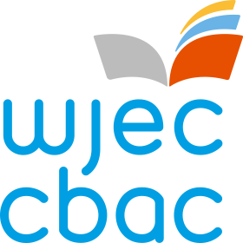

Please submit using the upload page
SCHOOL or COLLEGE:
STUDENT NAME:
PROJECT TITLE:

The Competition Explained
for participating schools and colleges in Bridgend County Borough, South Wales:
Year 12 students undertaking their Global Community Project as part of the Advanced Skills Baccalaureate Wales are invited to submit competition entries linked to Sustainable Wales’ key themes:
- Informed and active citizens
- A net-zero carbon and biodiverse society
- Local economy
- Resource management and waste prevention
- Healthy living and quality of life
- Responsible consumerism

Entries Will Be Judged On How Well They Address The Following Questions
1. The Problem – what is it?
2. Solutions – what are they, local or global?
3. Actions needed – what are the next steps to take for action as part of a Global Community?
Further information and entry details here: www.sustainablewales.org.uk/globalcitizenship
Final Entry Date: tbc

Your Entry
Ideal word count of around 500-750
(please add your entry below):

